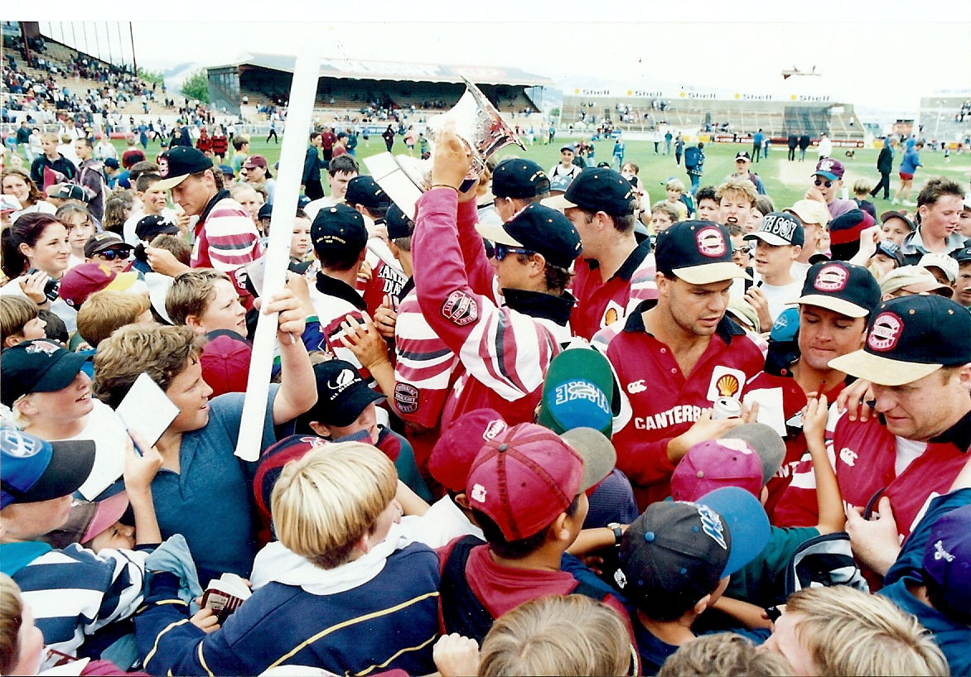

Signing autographs after winning the Shell Cup 1996